USB Car Charger Layout

Naseeruddin Lodge

USB Car Charger Schematic

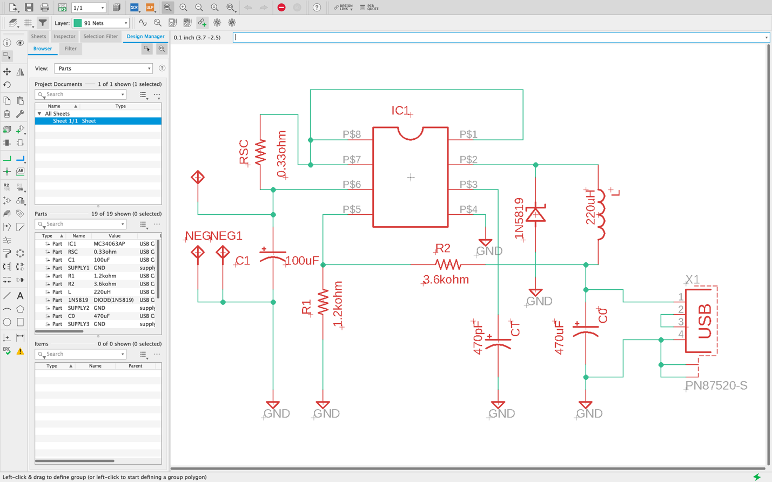

Error Check

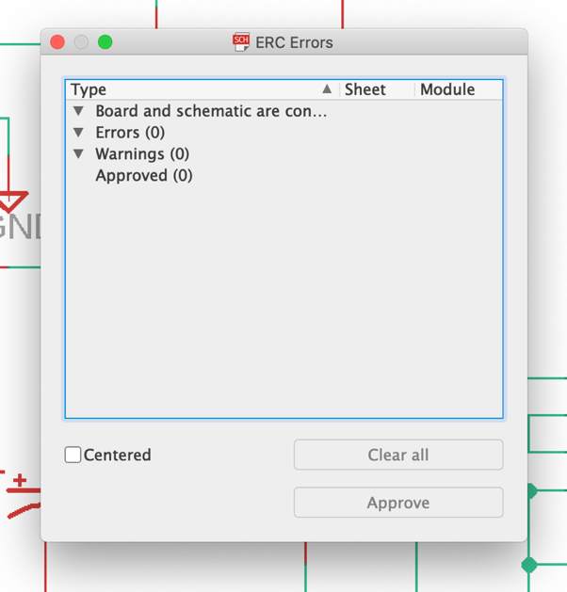

USB Car charger board routed

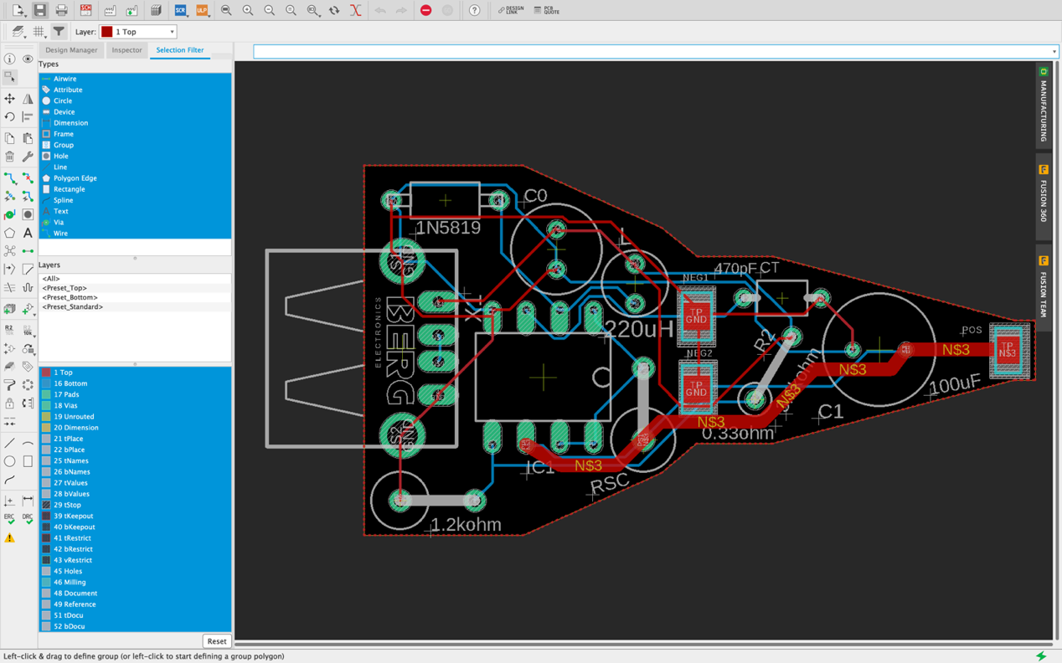

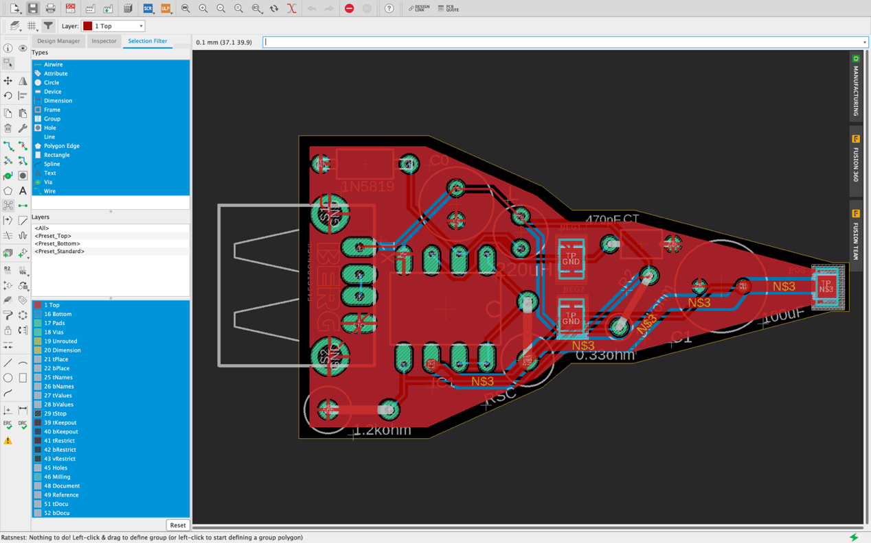

Error Check

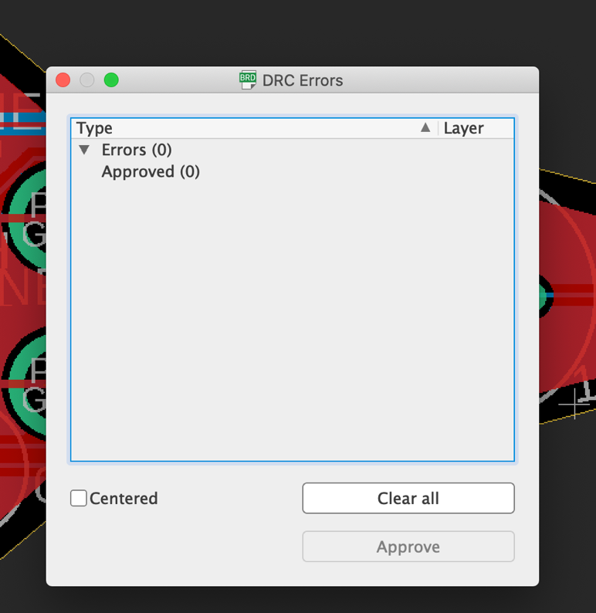

Silk Screen

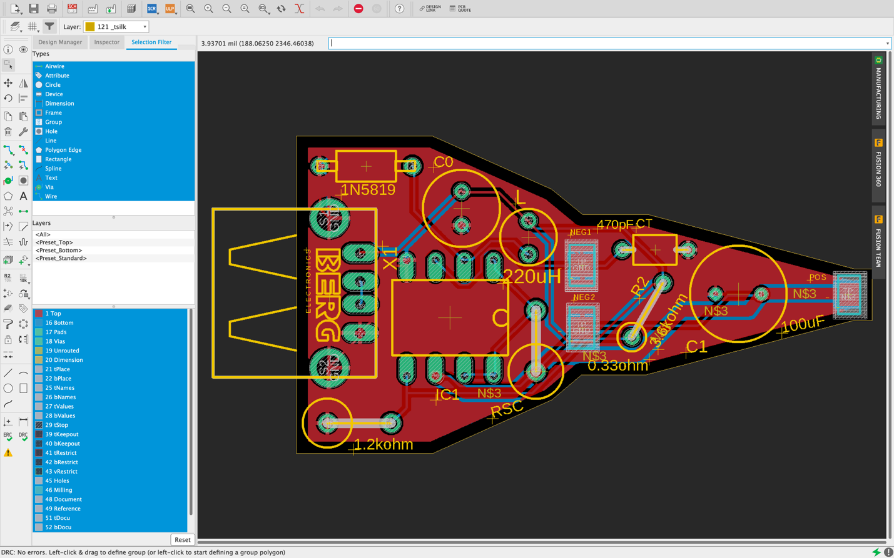

Top: Top, Pads, vias, Unrouted, Dimension, tPlace, tNames, tValues

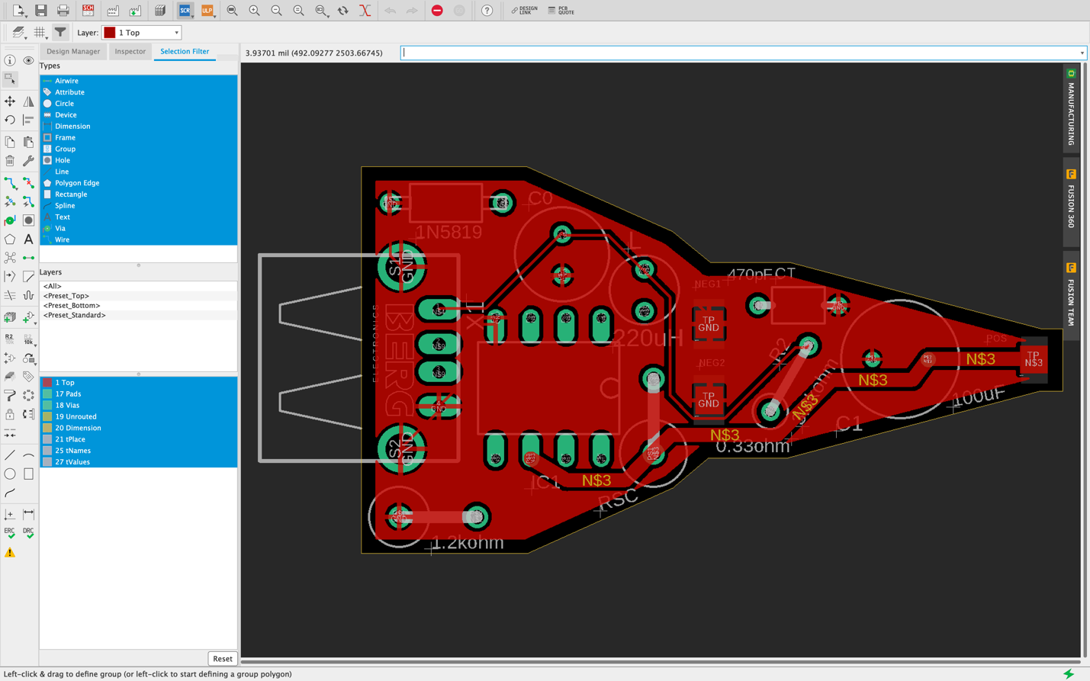

Bottom: Bottom, Pads, vias, Unrouted, Dimension, bPlace, bNames, bValues

